Sunday, October 18, 2009
By Karl Stark
31/2 stars out of 4
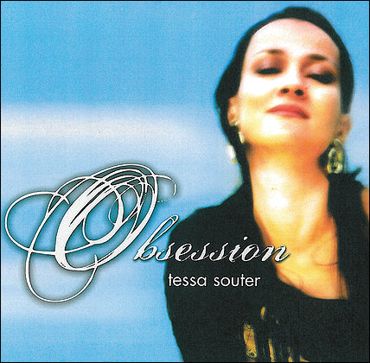
Singer Tessa Souter packs a smoky wallop. The London-born chanteuse with Trinidadian bloodlines and a San Francisco base comes with an unusual cocktail of influences. Singer Mark Murphy helped mentor her.
The best thing is that Souter sounds different. She does "Afro Blue" not to acknowledge servile guilt to an old songbook but to be expressive and take a different slant. She dips a lot into pop, but it's for slick choices like Nick Drake's "Riverman" (which recalls Andy Bey's great version). It's also in the service of a sleek vibe such as the meditative "Usha's Wedding," though that ditty ultimately disappoints.
Even a rock tune as familiar as Cream's "White Room" sounds distinctly Souterian, which is no small feat. Dori Caymmi's title track is a light tune that could use more bite. But Kenny Barron's "Crystal Rain" is full of passion, while "Love Theme for Spartacus" by Chester-born Alex North, a brief and daring duet with guitarist Jason Ennis, reminds me that there really is a love song buried in there.

